**Finding the perfect location for a bakery in SF**

Edison Li

September, 2020

1. **Introduction**
   1. Background  
        
      Mr Li operates the a bakery in San Francisco. His bakery is famous for making the best sourdough bread in the area.  
      Currently, his business is providing fresh sourdough to 30 American restaurants in San Francisco downtown area.
   2. Problem 1  
        
      Mr Li is planning to move his bakery to a new location.  
      In order to provide the freshest bread, he wants to find **a place that is right in the center all his current customers.** This would keep the total delivery time to his customer minimal and can ensure his customers getting the bread right out of his ovens.  
        
      Problem 2  
        
      Mr Li also has plans to expand his customer base to **90** in the next two years.  
      Since he already knows the locations of the 60 potential customers, he wants to determine **the optimal number of kitchens** to meet the extra demand and **the approximate locations of these kitchens.**
2. **Data acquisition**  
   2.1 Data sources  
   We are using foursquare API to get 90 restaurants around downtown San Francisco. In order to refine our search to American restaurants, we have modified out API call to include category id = “4bf58dd8d48988d14e941735”. This is the specific venue category for American restaurant (Figure 1).

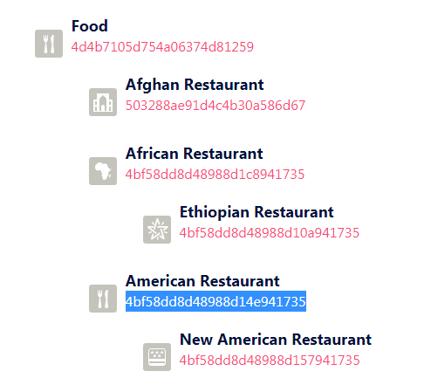  
Figure 1. List of venue categories specified in FourSquare

Afterwards, we put the customer name, venue category, longitude and latitude into a dataframe (Figure 2). The data is complete with no missing data.  
  
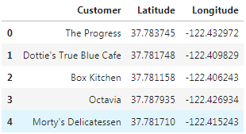  
  
Figure 2. The first 5 venues in our dataframe  
  
  
We have then assigned the first 30 venues as Mr Li’s existing customer while the other 60 will be the potential customers. We use folium to plot those locations in the map. All the current customers are listed in Figure 3 and all the existing and potential customers are listed in Figure 4.  
  
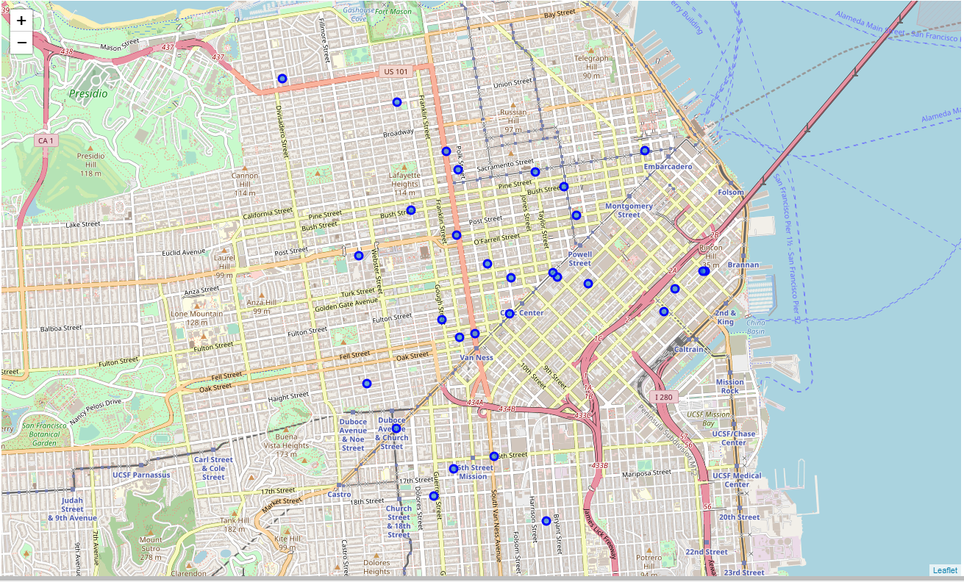

Figure 3. Mr Li’s existing customer distribution  
  
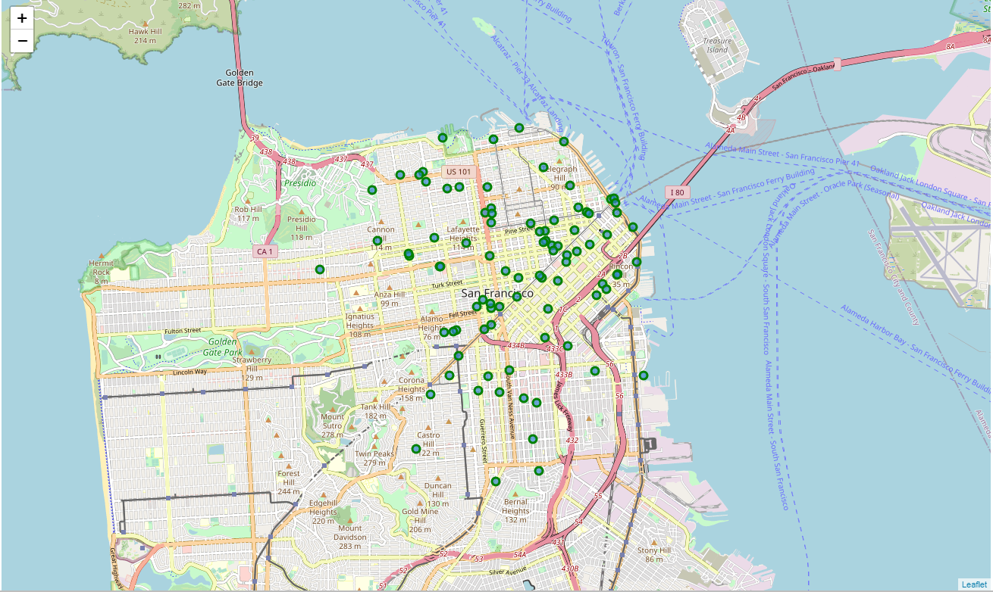  
  
Figure 4. Mr Li’s future customer distribution

1. **Clustering**

3.1 Existing customers  
  
In order to find the most optimal location for Mr Li’s bakery to serve his existing customers, we are doing a kmean clustering with a single centroid. That would give us the location that has the minimal mean distance to every other location in the cluster. In other word, the travel distance to all 30 locations would be minimized.

The resulting location is in this location (37.78118, -122.415941). A quick search in Google map has indicated that the address is **200 McAllister St, San Francisco, CA 94102** (Figure 5).

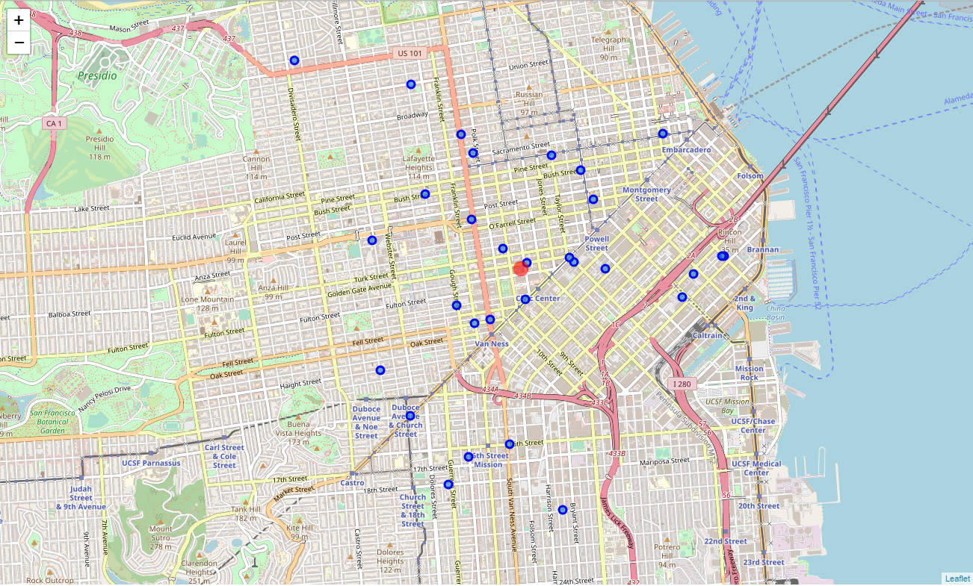  
  
Figure 5. Mr Li’s ideal location for his new bakery

3.2 Future customers  
  
For the future list of customers, we have executed kmean clustering 10 times with increasing number of centroids. After each iteration, we would calculate the sum of squares of the distances of each data point in all clusters to their respective centroids (WCSS) and plot the result (Figure 6). Using the elbow method, we have found that 3 bakeries would be the optimal number of location to serve 90 restaurants.  
  
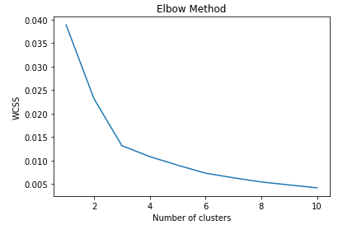  
  
Figure 6. WCSS against number of clusters. We can see that the curve becomes flatter at 3 clusters and that is why it would be the optimal number of clusters for this problem

After determining 3 clusters is needed, we have re-run kmean with 3 clusters and the locations are:   
 **412 Valencia St, San Francisco, CA 94103 (37.766236, -122.422152)**

**680 Mission Street, San Francisco, CA 94105 (37.786743, -122.402110)**

**2200 Pacific Ave, San Francisco, CA 94115 (37.794098, -122.432219)**

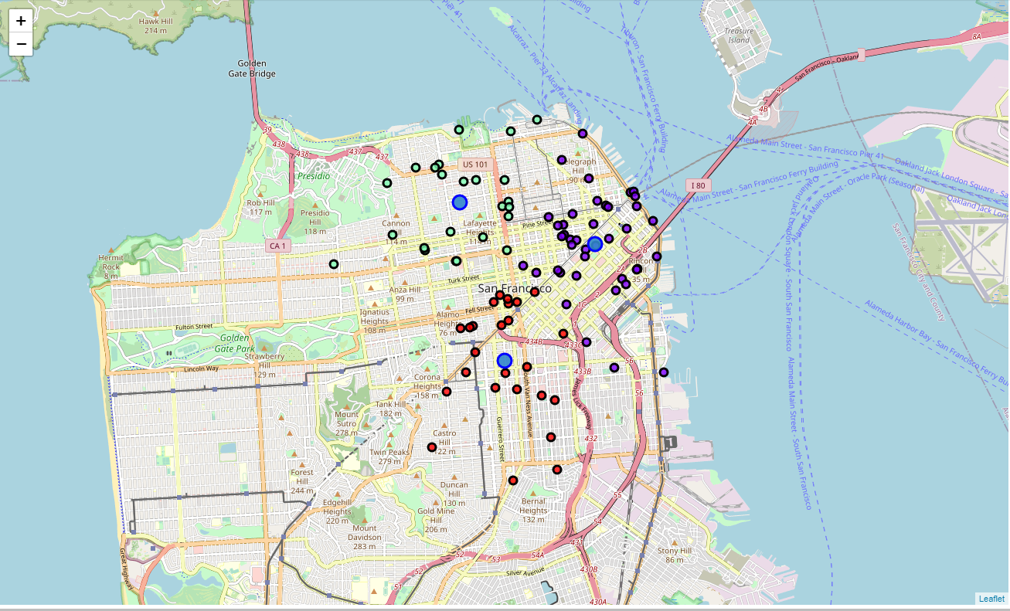

Figure 7. The 3 locations of Mr Li’s bakery to serve 90 customers in the future.

1. **Recommendations**  
     
   To serve his 30 existing customers, it would be best if Mr Li can move his bakery to **200 McAllister St, San Francisco, CA 94102** (37.78118, -122.415941) right now.   
     
   If Mr Li can acquire 60 new customers in the next two years, it would be best for him to move open 3 new locations as follow:  
     
   **412 Valencia St, San Francisco, CA 94103 (37.766236, -122.422152)  
   680 Mission Street, San Francisco, CA 94105 (37.786743, -122.402110)  
   2200 Pacific Ave, San Francisco, CA 94115 (37.794098, -122.432219)**
2. **Further analysis**  
   Even though we are fairly satisfied with our recommendations, we could enhance our model by modifying how distance between two locations is calculated. In our current model, we are using Euclidian distance. In order to get more realistic clustering, we could evaluate distance by the actual travel time between two locations. This change will add real life elements like the traffic flow and traffic condition to our model. We would expect the recommendations would reflect the real-life conditions better.